|  |  |
| --- | --- |
| **UNIT – IV** | **9 hours** |
| **Synchronous supply chain**- extended enterprise and the virtual supply chain- role of information- ‘Quick response’ logistics- Production strategies for quick response- Logistics systems dynamics  **Sustainable supply chain** - The triple bottom line- Greenhouse gases and the supply chain- Reducing the transport-intensity of supply chains – Carbon footprint and supply chain-Reduce, reuse, recycle | |

**INTRODUCTION**

In conventional supply chains each stage in the chain tends to be disconnected from the others. Even within the same company the tendency is for separate functions to seek to optimise their own performance. As a result the interfaces between organisations and between functions within those organisations need to be buffered with inventory and/or time lags. The effect of this is that **end-to-end pipeline times are long, responsiveness is low and total costs are high.**

To overcome these problems it is clear that the supply chain needs to act as a synchronised network – not as a series of separate islands. Synchronisation implies that each stage in the chain is connected to the other and that they all ‘march to the same drumbeat’. The way in which entities in a supply chain become connected is through shared information.

The information to be shared between supply chain partners includes **demand data and forecasts, production schedules, new product launch details and bill of material changes**.

To enable this degree of visibility and transparency, synchronisation requires a high level of ***process alignment*,** which itself demands a higher level of collaborative working. These are issues to which we shall return. The box below indicates some of the key processes that need to be linked, upstream and downstream, to provide the foundation for supply chain synchronisation.

|  |
| --- |
| **PRCOESSES in various links of SCM**  **Planning and scheduling:** Material positioning/visibility, advanced planning, scheduling, forecasting, capacity management.  **Design**: Mechanical design, electrical design, design for supply chain, component selection.  **New product introduction:** Bill of materials management, prototyping, design validation, testing, production validation, transfer to volume.  **Product content management:** Change generation, change impact assessment, product change release, change cut-in/phase-out.  **Order management:** Order capture/configuration, available to promise, order tracking, exception management.  **Sourcing and procurement:** Approved vendor management, strategic sourcing, supplier selection, component selection. |

Figure 1 depicts the difference between the conventional supply chain with limited transfer of information and the synchronous supply chain with network-wide visibility and transparency.

|  |
| --- |
|  |
| Key: OEM = Original equipment manufacturer  Tier 1 and 2 = Supplier echelons |

**Figure 1 Achieving synchronisation through shared information: (a) before**

**synchronisation; (b) after synchronisation**

**Benefits of Synchronizing**

A synchronized supply chain provides high levels of cus­tomer satisfaction with small levels of inventory invest­ment. Product delivery is improved; production cost is reduced. Synchronized operations maximize both throughput and profits resulting in high value to share­holders. On the other hand, synchronized operations are counterintuitive because they depend on both ex­cess capacity at every node and an agreement by every trading partner to a operate under a new set of rules.

**APPLYING SYNCHRONIZATION ACROSS THE SUPPLY CHAIN CONTINUUM**

 In some industries **large capital investment r**esults in ex­pensive plant and equipment being operated near full ca­pacity. Downstream final assembly is scheduled to maintain a customer order backlog, and customers expe­rience wide fluctuation in lead times for their orders. This situation is commonly found in aerospace, automotive, electronics, and durable goods industries where fluctua­tions in the utilization of large capital assets can result in financial investments spoiling. In this kind of environment, synchronization is best applied to the upstream feeder supply chains that converge at final assembly.

In other industries, **large inventory investments** in product having fixed shelf life result in production, transportation, and distribution being operated with a fixed lead time. Each node in the supply chain operates with excess capacity in order to maintain lead times throughout the system. This situation is commonly found in the grocery industry and the textile/ apparel industry where fluctuation in lead time can result in perishable food spoiling or in seasonal fashions falling out of style. In this kind of environment, synchroniza­tion can be used across the entire supply chain. Each node is synchronized to build or process tomorrow the quantity of product ordered today.

**STEPS TO SYNCHRONIZE A SUPPLY CHAIN**

When a group of independent organizations agree to cooperate as trading partners within a supply chain com­munity, they must go through the following steps to begin a synchronized operation:

•   Diagram the supply chain from raw materials to the end customer.

•      Prepare a master list of stock-keeping units (SKUs).

•      Pareto the SKU list by revenue (or by contribution margin).

•      Determine the trading partner node capacity required for synchronization over the expected range of de­mand uncertainty.

•      Identify the trading partner who is the system constraint.

•      Establish the days of supply for the constraint buffer and the shipping buffer.

•      Properly thread the demand signal to avoid the bullwhip effect.

•      Use collaborative push planning system to set the incoming rate of materials.

•      Use statistical safety stock on unique materials to support mix variation.

•      Define the operating rules at the push/pull boundary.

•      Spend supply chain resources to minimize the larg est standard deviation among supply uncertainty, cycle time variation, and transit time variation.

•      Maintain operational alignment through global per­ formance measures.

•      Hold periodic supply chain operations council meet­ings to resolve issues.

**The extended enterprise and the virtual supply chain**

The nature of business enterprise is changing. Today’s business is increasingly ‘boundaryless’, meaning that internal functional barriers are being eroded in favour of horizontal process management and externally the separation between vendors, distributors, customers and the firm is gradually lessening. This is the idea of the extended enterprise, which is transforming our thinking on how organisations compete and how value chains might be reformulated.

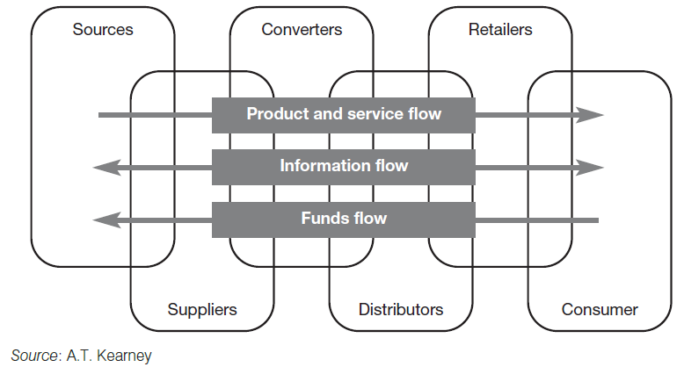

**Figure 2 The extended enterprise and the virtual supply chain**

**Underpinning the concept of the extended enterprise is a common information ‘highway’.** It is the use of shared information that enables cross-functional, horizontal management to become a reality. Even more importantly it is information shared between partners in the supply chain that makes possible the responsive flow of product from one end of the pipeline to another. What has now come to be termed the virtual enterprise or supply chain is in effect a series of relationships between partners that is based upon the value-added exchange of information. Figure 2 illustrates the concept.

The notion that partnership arrangements and a mentality of co-operation are more effective than the traditional arm’s-length and often adversarial basis of relationships is now gaining ground. Thus the **supply chain is becoming a confederation of organisations** that agree common goals and who bring specific strengths to the overall value creation and value delivery system. **This process is being accelerated as the trend towards outsourcing continues.** Outsourcing should not be confused with ‘subcontracting’ where a task or an activity is simply handed over to a specialist. In a way it would be better to use the term ‘in-sourcing’ or ‘re-sourcing’, when we refer to the quite different concept of partnering that the virtual supply chain depends upon. These partnerships may not be for all time – quite possibly they exist only to exploit a specific market opportunity – but they will be ‘seamless’ and truly synergetic.

**The role of information in the virtual supply chain**

Leading organisations have long recognised that the **key to success in supply chain management is the information system.** However, what we are now learning is that there is a dimension to information that enables **supply and demand to be matched in multiple markets, often with tailored products, in ever-shorter time-frames.**

This extension of the information system beyond the classical dimensions of simple planning and control enables time and space to be collapsed through the ability to link the customer directly to the supplier and for the supplier to react, sometimes in real time, to changes in the market.

Rayport and Sviokla have coined the term ‘**marketspace**’ to describe the new world of electronic commerce, internets and virtual supply chains. **In the marketspace, customer demand can be identified as it occurs and, through CAD/CAM and flexible manufacturing, products created in minimal batch sizes.** Equally, networks of specialist suppliers can be joined together to create innovative yet cost-effective solutions for complex design and manufacturing problems. The way that Airbus now designs and assembles its advanced aeroplanes, for example, would not be possible without the use of global information networks that link one end of the value chain to the other.

The **Internet has in many ways transformed the ways in which supply chain members can connect with each other.** It provides a perfect vehicle for the establishment of the virtual supply chain. Not only does it enable vast global markets to be accessed at minimal cost and allow customers to shorten dramatically search time and reduce transaction costs, but it also enables different organisations in a supply chain to share information with each other in a highly cost-effective way. ***Extranets* as they have come to be termed are revolutionising supply chain management.** Organisations with quite different internal information systems can now access data from customers on sales or product usage and can use that information to manage replenishment and to alert their suppliers of forthcoming requirements.

**One of Britain’s major retailers, Tesco, is using an extranet to link with its suppliers to share point-of-sale data.** At the same time the company is successfully running a home shopping and delivery system for consumers over the Internet. Within the business, *intranets* are in placethat enable information to be shared between stores and to facilitate communication across the business. We are probably even now only scraping the surface in terms of how the Internet and its associated technologies can be used to further exploit the virtual supply chain.

Figure 3 highlights some of the current applications of Internet-based concepts to supply chain management.

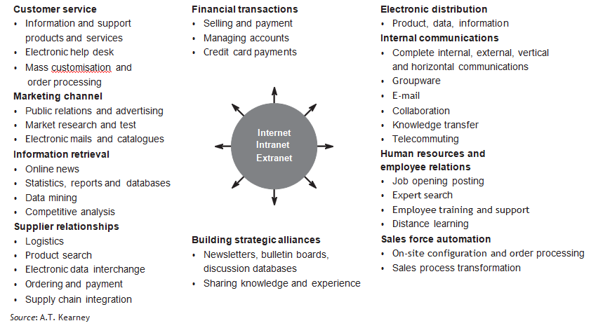

**Figure 3 Internet applications and the supply chain**

The IT solutions now exist to enable supply chain partners to share information easily and at relatively low cost. A major benefit that flows from this greater transparency is that the internal operations of the business can become much more efficient as a result. For example, by capturing customer demand data sooner, better utilisation of production and transport capacity can be achieved through better planning or scheduling. Figure 4 indicates some of the uses to which improved logistics information can be put.

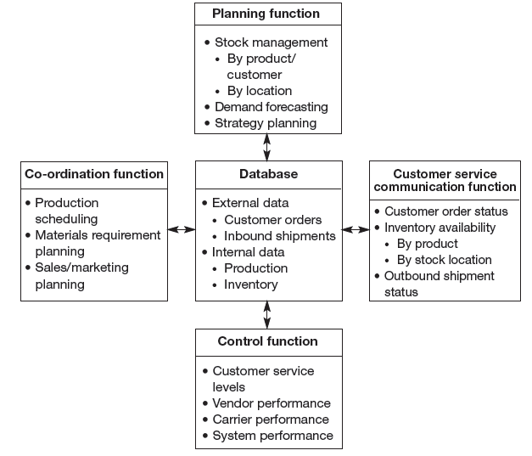

**Figure 4 Functions of a logistics information system**

**Increasingly, it seems that successful companies have one thing in common – their use of information and information technology to improve customer responsiveness.** Information systems are reshaping the organisation and also the nature of the linkages between organisations. Information has always been central to the efficient management of logistics but now, enabled by technology, it is providing the driving force for competitive logistics strategy.

We are now starting to see the **emergence of integrated logistics systems that link the operations of the business, such as production and distribution, with the supplier’s operations on the one hand and the customer on the other.** Already it is the case that companies can literally link the replenishment of product in the marketplace with their upstream operations and those of their suppliers through the use of shared information. The use of **these systems has the potential to convert supply chains into demand** chains in the sense that the system can now respond to known demand rather than having to anticipate that demand through a forecast. Figure 7.5 describes the architecture of such a system.

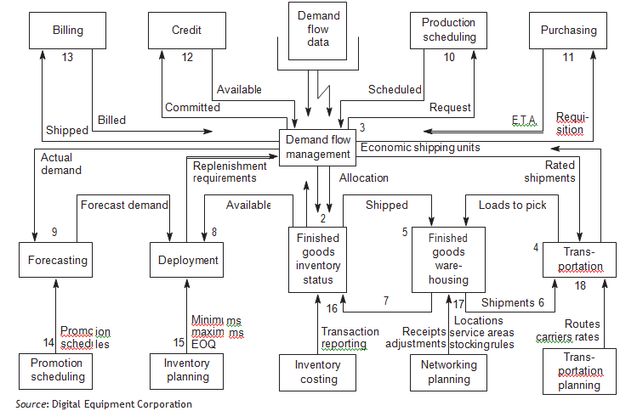

## Figure 7.5 An integrated logistics information system

**Laying the foundations for synchronisation**

In the same way that the **conventional wisdom in production and manufacturing is to seek economies of scale through larger batch quantities,** similar thinking can often be found in the rest of the supply chain. Thus companies might seek to ship by the container or truck load, customers are discouraged from ordering in smaller quantities by price penalties and delivery schedules are typically based on optimising the efficiency of routes and the consolidation of deliveries. **Clearly such an approach runs counter to the requirements of a synchronous supply chain.** Under the synchronisation philosophy the requirement is for small shipments to be made more frequently and to meet the precise time requirements of the customer.

The challenge to logistics management is to find ways in which these changed requirements can be achieved without an uneconomic escalation of costs. There may have to be trade-offs but the goal must be to improve total supply chain cost effectiveness.

The **basic principle of synchronisation** is to ensure that all elements of the chain act as one, and hence there must be early identification of shipping and replenishment requirements and, most importantly of all, **there must be the highest level of planning discipline.**

**In a synchronous supply chain the management of in-bound materials flow becomes a crucial issue**. In particular the search for consolidation opportunities has to be a priority. Thus, for example, rather than one supplier making a series of deliveries in small quantities to a customer, the orders from a number of suppliers are combined into a single delivery. It is perhaps not surprising that the emergence of synchronous supply chains as a management philosophy has coincided with the growth of **third-party distribution and logistics companies** specialising in providing an in-bound consolidation service.

These logistics service companies can manage the pick-up of materials and components from suppliers on a ‘milk round’ basis, using a central ‘hub’ or transhipment centre for resorting and consolidating for in-bound delivery. They may also perform certain value-adding activities such as quality control, kitting, sequencing or final finishing. In complex assembly operations such as motor manufacture the prior sequencing of parts and components prior to assembly is a crucial activity

Similar developments have enabled the transformation of retail logistics. **The idea of ‘stockless distribution centres’ or ‘cross-docking’ enables a more frequent and efficient replenishment of product from manufacture to individual stores**. Cross- docking, often facilitated by a logistics service provider, is a simple, but powerful, concept. Point-of-sale data from individual stores is transmitted to the retailer’s head office to enable them to determine replenishment requirements. This information is then transmitted directly to the suppliers who assemble orders for specific stores and the pallets or cases are then bar-coded (or increasingly electronically tagged). On a pre-planned basis these store orders are then collected by the logistics service provider and are taken to a transhipment centre (the ‘cross- dock’ facility) – possibly operated by the logistics service provider – where they are sorted for store delivery along with other suppliers’ orders. In effect, a just-in- time delivery is achieved, which enables minimum stock to be carried in the retail stores, and yet transport costs are contained through the principles of consolidation (see Figures 6 and 7).

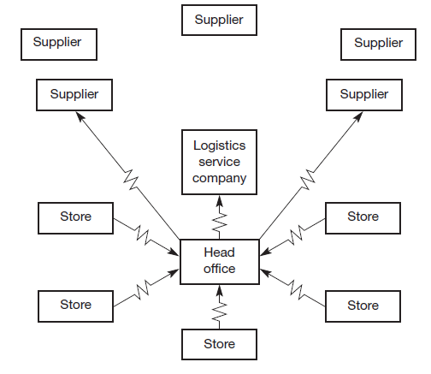

**Figure 6 Daily sales data drives the replenishment order system**

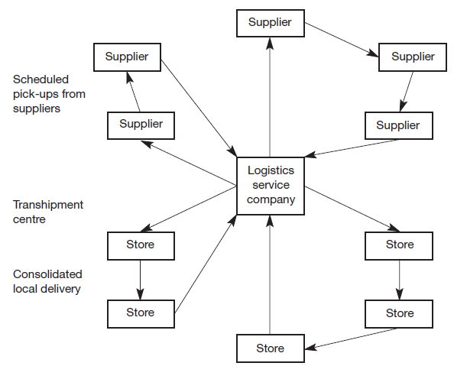

**Figure 7 Acting on this information a consolidated pick-up and store delivery sequence is activated**

**‘Quick response’ logistics**

An outgrowth of the synchronisation philosophy has emerged in recent years under the banner of ‘quick response’ logistics.**The basic idea behind quick response (QR) is that in order to reap the advantages of time-based competition it is necessary to develop systems that are responsive and fast.** Hence QR is the umbrella term for the information systems and the logistics systems that combine to provide ‘the right product in the right place at the right time’.

**What has made QR possible** is the development of information technology and in particular the rise of Internet-enabled data exchange, bar coding, the use of electronic point-of-sale (EPOS) systems with laser scanners and so on.

Essentially the logic behind QR is that demand is captured in as close to real-time as possible and as close to the final consumer as possible. The logistics response is then made directly as a result of that information.

An example of such an approach is provided in the United States by Procter & Gamble which receives sales data directly from the check-out counters of North America’s largest retailer, Wal-Mart. Making use of this information P&G can plan production and schedule delivery to Wal-Mart on a replenishment basis. The result is that Wal-Mart carries less inventory yet has fewer stock-outs and P&G benefits from better economies in production and logistics as a result of the early warning and – most importantly greatly increased sales to Wal-Mart. Whilst the investment in the information system is considerable, so too is the payback.

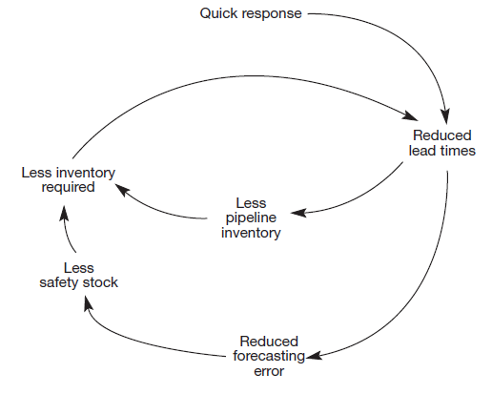

**Figure 8 Quick response system can trigger a ‘virtuous circle’ in logistics**

**A further feature in favour of QR systems is that by speeding up processing time in the system, cumulative lead times are reduced.** This can then result in lower inventory (see Figure 8) and thus further reduce response times. In effect a ‘virtuous circle’!

Quick response systems have begun to emerge in the fashion and apparel industry where the costs of traditional inventory-based systems based upon buyers’ prior purchase decisions (in effect a ‘push’ system) can be considerable. In the United States it is estimated that the annual costs to the US textile and apparel industry of conventional logistics systems is $25 billion. This comprises the following elements:

|  |  |
| --- | --- |
| Forced markdowns | $14.08bn |
| Stock-outs | $6.08bn |
| Inventory carrying costs | $5.08bn |
| Total: | $25.24bn |

There could be massive advantages to be gained by all parties in the supply chain if the concept of QR was adopted throughout the chain. Thus in the case of fashion garments the aim should be to link retail sales with the apparel manufacturers, who in turn are linked to the textile producers who themselves are linked to the suppliers of fibres.

**One such reported case is the linkage through shared information of the US textile company Milliken with the Seminole Manufacturing Company** (a manufacturer of men’s slacks) and the retailer Wal-Mart. Information on end-user demand was captured at the point-of-sale and rapidly fed back up the supply chain, enabling dramatic reductions in lead times to be achieved and hence substantial reductions in inventory.

**Another case from the US is provided by the chain of retail fashion stores, The Limited**. Each of the several thousand stores in the chain tracks consumer preferences daily using their point-of-sale data. Based upon this, orders are sent by satellite links to the suppliers around the world. Using Hong Kong as a consolidation centre, goods are flown back to The Limited’s distribution centre in Columbus, Ohio. At the distribution centre the goods are price-marked and resorted for immediate onward shipment by truck and plane to the retail stores. **The whole cycle from reorder to in-store display can be achieved in six weeks. Conventional systems take more like six months.**

**Production strategies for quick response**

As the demand by all partners in the supply chain for a quick response increases, the greater will be the pressure placed upon manufacturing to meet the customer’s needs for variety in shorter and shorter time-frames.

**The answer has to lie in flexibility.** As we have already observed, if it were possible to reduce manufacturing and logistics lead times to zero then total flexibility could be achieved. In other words the organisation could respond to any request that was technologically feasible in any quantity. **Whilst zero lead times are obviously not achievable, the new focus on flexible manufacturing systems (FMS) has highlighted the possibility of substantial progress in this direction.**

The key to flexibility in manufacturing is not just new technology, e.g. robotics, although this can contribute dramatically to its achievement. **The main barrier to flexibility is the time taken to change; to change from one level of volume to another and to change from making one variant to another**. Typically we call this ‘set-up time’. It will be apparent that if set-up times can be driven as close as possible to zero then flexible response to customer requirements presents no problem.

The Japanese, not surprisingly, have led the way in developing techniques for set-up time reduction. ‘**Single minute exchange of** die’, or SMED, is the goal in many Japanese plants. In other words continuous attention by management and the workforce is focused upon the ways in which set-up times can be reduced. Sometimes it will involve new technology, but more often than not it is achieved through taking a totally different look at the process itself. In many cases set-up times have been reduced from hours down to minutes, simply by questioning the conventional wisdom.

What in effect we are seeing is a **fundamental shift away from the economies of scale model,** which is volume based and hence implies long production runs with few change-overs, to the economies of scope model, which is based upon producing small quantities of a wider range, hence requiring more change-overs.

It has been suggested that under the economies of scope model:

*… a single plant can produce a variety of output at the same cost as (if not lower than) a separate plant, dedicated to producing only one type of product at a given level. In other words an economic order quantity (EOQ) of one unit, and specific production designs, engender no additional costs. Economies of scope change the materials-driven, batch-system technology into a multi-functional, flow system configuration.*

SOURCE: D. LEI AND J.D. GOLDHARS

The marketing advantages that such flexibility brings are considerable. It means that in effect the company can cater for the precise needs of **multiple customers,** and they can offer even **higher levels of customisation**. In today’s marketplace where customers seek individuality and where segments or ‘niches’ are getting ever smaller, a major source of competitive advantage can be gained by linking production flexibility to customers’ needs for variety.

A **classic example is provided by Benetton,** the Italian fashion goods manufacturer and distributor, which has created a worldwide business based upon responsiveness to fashion changes – with a particular emphasis upon colour. By developing an innovative process whereby entire knitted garments can be dyed in small batches, they reduced the need to carry inventory of multiple colours, and because of the small batch sizes for dying they greatly enhanced their flexibility. Benetton’s speed of response is also assisted by the investment that they have made in high-speed distribution systems, which are themselves aided by rapid feedback of sales information from the marketplace.

Many companies are now seeking to construct supply chains to enable them to support a marketing strategy of ***mass customisation*.** The idea behind this is that today’s customers in many markets are increasingly demanding tailored solutions for their specific requirements. The challenge is to find ways of achieving this marketing goal without increasing finished goods inventory and without incurring the higher costs of production normally associated with make-to-order.

Often this can be achieved by postponing the final configuration or assembly of the product until the actual customer requirement is known – a strategy pursued by Dell and Hewlett Packard, for example.

In other cases high technology in the form of computer-aided design/computer-aided manufacturing (CAD/CAM) can provide the means for this mass customisation.

**Logistics systems dynamics**

One of the major advantages of moving to QR and synchronous supply chain strategies is that, by reducing lot quantities and increasing the rate of throughput in the logistics system, modulations in the level of activity in the pipeline can be reduced.

**Logistics systems are prone to what has been called the ‘Bullwhip’ or ‘Forrester Effect’,** after Jay Forrester, who developed a set of techniques known as Industrial Dynamics.Forrester defined industrial dynamics as:

*The study of the information feedback characteristics of industrial activity to show how organizational structure, amplification (in policies) and time delays (in decisions and returns) interact to influence the success of the enterprise. It treats the interactions between the flows of information, money, orders, materials, personnel, and capital equipment in a company, an industry or a national economy.*

Using a specially developed computer simulation language, **DYNAMO**, Forrester built a model of a production/distribution system involving three levels in the distribution channel: a retailer’s inventory, a distributor’s inventory and a factory inventory. Each level was interconnected through information flows and flows of goods. The model used real-world relationships and data and included parameters such as order transmission times, order processing times, factory lead times and shipment delivery times. Management could then examine the effects on the total system of, say, a change in retail sales or the impact of changing production levels or any other policy change or combination of changes.

## What is the Bullwhip Effect?

If you ever observed how a whip works, or just tried to wiggle a rope from one tip, you’ll notice that a small movement of your wrist can cause a tremendous effect at the opposite tip. Interestingly, this effect happens in the same way in commercial distribution chains, if you just think of your wrist as a variation in consumer demand, and the tip of the whip as the manufacturing sector. The bullwhip effect can be explained as a phenomenon that happens when manufacturers and suppliers receive orders that are far away from the real number of sales to the end customer. These irregular numbers of orders can develop high fluctuations in the supply chain as the regular flow of supply and demand are not in sync, and each link in the supply chain will over or underestimate how much they need to produce/supply, resulting in unpredictable price fluctuations.

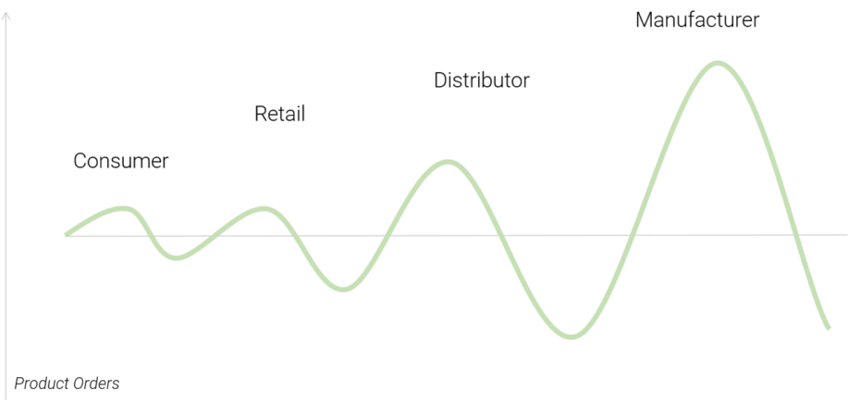

## Explaining with an Example

Consumers suddenly start buying a certain food product in higher amounts than usual. Instead of regular 100 units sold, a supermarket suddenly sells 150. The supermarket puts an order to the supplier for 200 units, just in case the supply keeps increasing. The supplier only deals with bulk orders monthly, so they order enough to supply 250 units weekly for the next month. The manufacturer then has more than doubled demand for the next month and scales their production capacity to cope with it. In the end, 5 times more goods are produced than the actual consumer demand, which will massively drive prices down across the supply chain.

As you can probably already identify, **different causes lead to this effect**. Some of them include **unbalanced estimations** from the part of distributors, **order batching** at some points of the supply chain, and often the **lack of communication** **and sync** between the different links of the chain. However, **a big issue is on the manufacturer side in industries where production scaling is a slow process.**

Here specifically, we talk about the food industry and the problems it faces in this regard.

## A Particular Problem in the Food System: If we set up a thought experiment where there is a sudden demand of particular food products by consumers, and in the other end the product relies on agriculture to produce such products, some of the problems become evident. Growing of plants and animals for consumption, especially in the production of fresh and perishable goods, is notably a process that cannot simply be upscaled or downscaled in quick response times. Taking soybean as an example (the largest source of plant-based protein worldwide), the plants would take 3 to 5 months from seed to harvest. If the market has a sudden shift in demand on the consumer side, it takes the supply chain around half a year to respond to such an effect.

If we combine such an effect with the fact that some goods are produced only in specific locations, the consequences in times of crisis can be deeply felt. Taking again the case of **Soybean production, Brazil produces 36% of all the global supply** (By 2020). A catastrophe at a national level in production or export could severely hinder the world supply in a way that would take the world at least half a year to respond to, and the effects on the fluctuating and desynchronized supply and demand across the distribution chain would be felt for years to come. In this case, the effect would be felt not only directly in the food market, but also indirectly due to disruptions in the feed and consequently, animal products industries.

**What becomes apparent from this modelling of complex systems is that small disturbances in one part of the system can very quickly become magnified as the effect spreads through the pipeline.**

For example, many consumer product companies that are heavy spenders on trade promotions (e.g. special discounts, incentives, etc.) do not realise what the true costs of such activities are. In the first instance there is the loss of profit through the discount itself, and then there is the hidden cost of the disturbance to the logistics system. Consider first the loss of profit. When a discount is offered for a limited period then that discount obviously will apply to all sales – not just any incremental sales. So if sales during the promotional period are, say, 1,100 cases but without the promotion they would have been 1,000, then whilst the incremental revenue comes only from the additional 100 cases, the discount applies to all 1,100. Additionally the retailer may decide to take advantage of the discount and ‘**forward order**’; in other words buy ahead of requirement to sell at a later time at the regular price. One study found that for these reasons **only 16 per cent of promotions were profitable,** the rest only ‘**bought sales’** at a loss.

The **second impact of promotional activity** on profit is the potential it provides for triggering the **‘acceleration effect’** and hence creating a **Forrester-type** surge throughout the logistics pipeline. This is because in most logistics systems there will be **‘leads and lags’**, in other words the response to an input or a change in the system may be delayed. For example, the presence of a warehouse or a stock holding intermediary in the distribution channel can cause a substantial distortion in demand at the factory. This is due to the **‘acceleration effect’**, which can cause self-generated fluctuations in the operating characteristics of a system.

As an example, imagine a retailer with an inventory management reordering strategy based on starting each week with the equivalent of three weeks’ demand in stock. So if weekly demand were 100 units for a particular item the target starting inventory would be 300 (i.e. 100 × 3). Now let us assume that as a result of a promotion demand increases by 10 per cent to 110. This means that the system would place an order to bring the next week’s starting inventory up to 330 (i.e. 110 × 3). So the reorder quantity would have to be 140 (i.e. the 110 units sold to consumers plus the extra 30 required to meet the new starting level).

In this particular case an increase in consumer demand of 10 per cent leads to a one-off increase in demand on the supplier of 40 per cent!

If in the next period consumer demand were to fall back to its old level then the same effect would happen in reverse.

It is not unusual for companies undertaking frequent promotional activity to experience considerable upswings and downswings in factory shipments on a continuing basis. Figure 9 illustrates the lagged and magnified effect of such promotional activity upon the factory. It can be imagined that such unpredictable changes in production requirements add considerably to the unit costs of production.

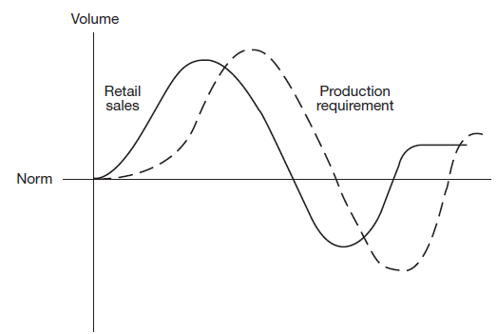

**Figure 7.9 The impact of promotional activity upon production requirement**

In the grocery industry, where much of this promotional activity is found, there is a growing recognition of the need to achieve a closer linkage between the ordering policies of the retail trade and the manufacturing schedules of the supplier. In the United States it was estimated that the time from the end of the production line to purchase by the consumer in a retail store was 84 days for a typical dry grocery product (see Figures 10 and 11).

This means that the ‘tidal wave’ effect of changes in demand can be considerably magnified as they pass through all the intermediate stock holding and reorder points. One of the benefits of a quick response system is that by linking the retail check-out desk to the point of production through electronic data transfer, the surge effect can be dramatically reduced. This fact alone could more than justify the initial investment in linked buyer/supplier logistics information systems.

|  |
| --- |
| Figure 10 Grocery industry delivery system order cycle |
| Figure 11 Grocery industry product flow |

# **References**

* 1. Rayport, J.F. and Sviokla, J.J., ‘Managing in the marketspace’, *Harvard Business Review*, November–December 1994.
  2. Chandrashekar, A. and Schary, P., ‘The virtual web-based supply chain’, in Franke, U. (ed.), *Managing Virtual Web Organizations in the 21st Century*, Idea Group Publishing, 2002.
  3. Heinrich, C., *Adapt or Die: Transforming your Supply Chain into an Adaptive usiness Network*, John Wiley & Sons, 2003.
  4. Lowson, R., King, R. and Hunter, A., *Quick Response: Managing the Supply Chain to Meet Consumer Demand*, John Wiley & Sons, 1999.
  5. Lei, D. and Goldhars, J.D., ‘Computer-Integrated manufacturing: redefining the anufacturing firm into a global service business’, *International Journal of Operations & Production Management*, Vol. 11, No. 10, 1991.
  6. Forrester, J., *Industrial Dynamics*, MIT Press, 1961.
  7. Abraham, M.M. and Lodish, L.M., ‘Getting the most out of advertising and promotion’, *Harvard Business Review*, May–June 1990.

|  |  |
| --- | --- |
| UNIT – VII | **6 hours** |
| **SUSTAINABLE SUPPLY CHAIN**  - The triple bottom line- Greenhouse gases and the supply chain- Reducing the transport-intensity of supply chains – Carbon footprint and supply chain-Reduce, reuse, recycle | |

Perhaps one of the biggest issues to rise to prominence across every aspect of business and society in the opening years of the twenty-first century has been ‘**sustainability**’. The growing concern with the environment, in particular the possibility of climate change through global warming, has led to a focus on how human and economic activity has the potential to adversely impact the long-term sustainability of the planet.

The definition of sustainability that is most widely used originates from the United Nations Brundtland Commission, which reported in 1987. Sustainability, the Commission suggested, was about

***meeting the needs of the present without compromising the ability of future generations to meet their own needs.***

# **The triple bottom line**

This definition can be further augmented by adopting the parallel idea of the ‘triple bottom line’.The triple bottom line concept emphasises the importance of examining the impact of business decisions on three key arenas:

Environment (e.g. pollution; climate change; the depletion of scarce resources, etc.)

Economy (e.g. effect on people’s livelihoods and financial security; profitability of the business, etc.)

Society (e.g. poverty reduction; improvement of working and living conditions, etc.)

These three elements – the 3Ps of **people, profit and planet** – are inevitably inter- twined and they serve to remind us that for a business to be truly sustainable, it must pay regard to the wider impact of the activities it undertakes if it seeks to remain viable and profitable (see Figure 1).

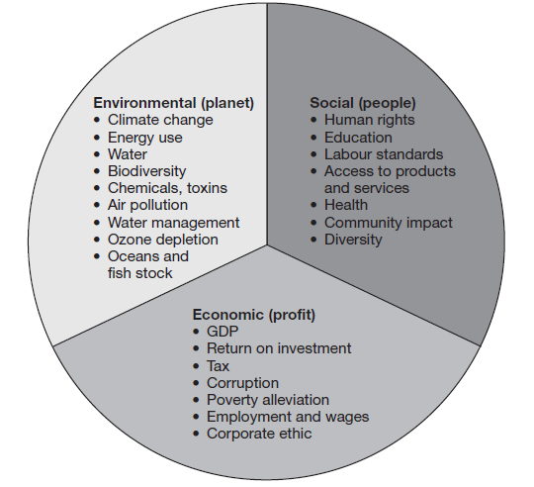

**Figure 1 The triple bottom line: planet, people, profit (Source Accenture)**

In the context of supply chains we can build on the triple bottom line philosophy to compass the wider idea that sustainability is concerned with **ensuring the long- term viability** and continuity of the business as well as contributing to the **future well-being of society**. Indeed, it can be argued that **these two goals are mutually supportive, i.e. supply chain strategies that benefit the wider environment are likely also to involve the business in less cost in the long term as the result of a better use of resources.** For example, one element in a ‘**green’** supply chain might involve utilizing transport capacity more efficiently through better routing and scheduling. In so doing, not only is the environmental impact of transport reduced, but also the cost to the company.

Because the **supply chain underpins the efficient and effective running of the business it can provide a useful framework for exploring opportunities for improving sustainability.** If we adopt the philosophy that the supply chain ‘begins on the drawing board’, i.e. that product design decisions impact subsequent supply chain costs, it makes sense to look at sustainability across the entire product life cycle. In other words, we need to understand the impact on sustainability of everything we do from product design through to end- of-life disposal.

**Greenhouse gases and the supply chain**

Recent years have seen a considerable growth of awareness of the potential harm to the environment that can be caused by so-called ‘**greenhouse gases’**. These gases include carbon dioxide, methane and nitrous oxide and various fluorocarbons. Generically these emissions as they relate to an activity are often referred to as its ‘**carbon footprint’**. As a result of increased economic activity around the world, the level of these greenhouse gases has risen significantly over the years. It is estimated that current levels are around 430 parts per million compared to 280 parts per million before the Industrial Revolution.

A view that is held by many, although not all, commentators is that this increase in greenhouse gas levels has been, and is, a **major cause of climate change**. A number of influential reports have brought these issues to the attention of governments, industry and the wider public on a global scale. **Even though it has proved difficult to get universal agreement on the best means for reducing greenhouse gas emissions, there is a widespread acknowledgement that action is required.**

For supply chain managers this is a particular call to action since **some of the major causes of greenhouse gases arise from industrial activities such as manufacturing, energy production and transportation.** In the specific case of freight transport, for example, it is acknowledged that as a result of the globalisation of supply chains we are now moving products greater distances than ever before with a consequent impact on the carbon footprint. The example of the laptop used by Thomas Friedland, the author of *The World is Flat*, is a case in point. He estimated that the approximately 400 different components in his Dell computer had travelled hundreds of thousands of miles from all their different sources and through the assembly and distribution process to reach him.

In recent years there has been a **growing awareness amongst consumers of the issue of ‘food miles’ – in other words how far food travels from its origin to the point of final consumption** – and what the impact of this might be on carbon emissions. The item highlighted below is indicative of this growing concern.

|  |
| --- |
| **12,000-mile round trip to have seafood shelled**  A seafood firm was accused of ‘environmental madness’ ~~yesterday~~ for choosing to send langoustines on a 12,000-mile round trip to Thailand to have their shells removed.  Langoustines look like **large prawns** but are actually more closely related to a **lobster**. Also often known as Dublin Bay prawns, Nephrops and Norwegian lobster, langoustine (Nephrops norvegicus) look like large prawns but are actually part of the lobster family and can grow up to 250g in weight.  After the shellfish are caught in Scottish waters they will be frozen and shipped to the Far East where they will be peeled by hand and sent back to be sold as scampi. The move by Young’s Seafood is costing 120 jobs at a plant in Annan, south-west Scotland, where the langoustines have been peeled mechanically.  The firm claims that removing the shells by hand enhances the taste, but UK wage costs – **at £6 an hour, compared with about 25p an hour in Thailand** – are prohibitive.  Friends of the Earth Scotland said the move was ‘madness and would add to global warming’.  *SourcE*: CRAmB, A., ‘12,000-mIlE  RoUND TRIP To HAvE SEAFooD SHEllED’, *Daily TElEgraph*, 16 NovEmBER 2006 |

Whilst at the moment the environmental costs incurred as a result of commercial activity are not generally borne by the companies that cause them, this will **almost certainty change as a result of carbon taxes, emission trading schemes and regulatory change**. Hence the need for supply chain managers to think hard about alternative strategies.

**Reducing the transport-intensity of supply chains**

As global economic growth continues, so too does international trade increase and hence transport. The **continued upward trend in global sourcing has inevitably led to products travelling greater distances.** The end result is an increase in what might be termed the *transport-intensity* of the supply chain. Transport intensity can be measured in a number of ways, but at its simplest it is a reflection of the miles/ kilometres travelled per unit of product shipped. Since the transport of raw material and finished goods globally is estimated to consume 15 million barrels of oil each day – almost one fifth of the world’s daily production – there is clearly a correlation between transport intensity and a supply chain’s carbon footprint. Not only is there an economic benefit to be gained by improving transport intensity but also a potential positive environmental impact – this is the concept of *eco-efficiency*, which is now rapidly becoming a major issue in global commerce.

**What practical steps can organisations take to improve the transport-intensity of their supply chains?**

***review product design and bill of materials***

Product design can impact transport-intensity through the physical characteristics of the product, its density, the choice of materials (including packaging materials), the ease of recycling, reuse and end-of-life disposal.

***review sourcing strategy***

As we have previously noted, many sourcing decisions have led to a migration to low-cost country locations. This often has led to products being moved greater distances. Global sourcing decisions will increasingly need to factor the carbon footprint into the total cost of ownership.

***review transport options***

Clearly different transport modes have different impacts on carbon and other emissions. The design of vehicles and vessels is also increasingly influenced by the need to improve fuel efficiency. There are also arguments for increasing the size of vehicle or the vessel to achieve lower transport intensity per unit. For example, new-generation container ships such as the *Emma Maersk.*

***Improve transport utilisation***

Research has highlighted that vehicle capacity is often poorly utilised. It is suggested that empty running because of the lack of return loads means that up to a third of the trucks on the roads of Europe are running empty! More use of shared distribution, better vehicle routing and scheduling, and better loading can also dramatically improve transport-intensity.

***Use postponement strategies***

If standard, generic products can be shipped in bulk from their point of origin and then assembled, customised or configured for local requirements nearer the point of use, there may be an opportunity to reduce overall transport-intensity.

A further incentive to reduce the transport-intensity arises from the continued upward pressure on oil-based fuel costs, which will only intensify as oil reserves become depleted.

**Consider a number of transportation strategies that can be used by management to help reduce costs.**

**Fewer Carriers**

In the same way that the purchasing department streamlines vendors to gain better prices with higher volume, the transportation manager should adopt the same strategy when it comes to the number of carriers used.

A transport manager spends time finding the best carrier at the best price, but sometimes that leads to a large number of carriers being used, albeit giving excellent service. The multiple carrier approach occurs when the transport manager has negotiated the best deal for each route but has not looked at the big picture.

By reducing the number of carriers, the amount of work offered to the remaining carriers will increase. By offering vendors a larger volume of work, the carrier should be able to offer lower rates across all routes. It may be the case that on some routes the rate is not as good as was negotiated with another carrier, but overall the rates across all routes should be lower.

As carriers are offered more work, theoretically the negotiated rates should fall even more as the carrier wants to retain the routes they have and increase the volume of work they are receiving.

Of course, with any strategy, there is also a downside. The risk associated with only using a small number of carriers is that a company can become very dependent on those carriers.

If a company uses five carriers fairly equally and one of those carriers goes out of business, the company would quickly have to find carriers to allocate those routes. Otherwise, delivery delays could cause financial consequences with customers not receiving their deliveries and a drop in customer satisfaction which could lead to fewer orders in the future.

**Consolidating Shipments**

If a company uses carriers for its deliveries, the rate it pays is negotiated by trip based on weight, distance, and other variables.

One strategy that can be used by transportation managers is to consolidate shipments so that fewer trips are made, and the company reaps the benefit of lower rates based on larger shipments.

Consolidating shipments means that transportation managers will be moving away from less than truckload (LTL) shipments to truckload (TL) shipments. This is not always possible, but given that discounts for larger shipments are almost always available, the transportation manager should be looking at this strategy to reduce costs.

**Single Sourcing**

Some companies believe the best-negotiated prices can be achieved when they use a single source for all their transportation. This is fairly common for purchasing departments to use a single source for a range of products that a single vendor can provide.

The same can be achieved for transportation. By offering all transportation out to bid, via a request for quotation (RFQ), a company can provide carriers with a detailed explanation of what it requires, which may fall outside of what is normally provided by a common carrier.

If it wanted to use a single source, a company would have to thoroughly evaluate a bidder’s ability to provide the service and whether the carrier has the stability not fall into bankruptcy within the timeline of the contract. If the winning bidder fulfills the needs of the company and has been fully evaluated, a company could gain significant transportation savings using a single carrier.

**Peak oil**

**The concept of ‘peak oil’ originated as far back as 1956 when Dr marion King Hubbert, a geologist at Shell, first coined the phrase.** What he recognised was that all oil production, whether from an individual field, a country or the entire world, follows a normal distribution, i.e. a bell-shaped curve. All the current indications are that we have reached the top of that curve, or that we shortly will. Even with new discoveries, the total amount of oil reserves will still be in decline once the peak has passed.

At the moment the world demand for oil is approximately 85 million barrels a day, which by chance is about the current daily output of all the working fields. However, whilst output will inevitably decline as ‘peak oil’ is passed, world demand is likely to grow – particularly fuelled by economic growth in countries such as India and China. **The gap between demand and supply will get larger by the day.**

Some commentators have suggested that the gap between the demand and supply for oil will be filled by the **discovery of new oil fields or the development of new fuels** (e.g. bio-fuels). However, such is the likely deficit that it is estimated that we would need to find new reserves of oil (or create alternative fuels) equivalent to five Saudi Arabias over the next 20 years. Simple economics tells us that the only way that the gap will actually be closed is by the price mechanism. In other words, the cost of oil will increase dramatically to reflect the shortfall in supply.

Today’s supply chains are more energy intensive than before because they are more transport intensive than they used to be. There are a number of reasons for this including:

* **Focused factories and centralised distribution** – as a result of rationalising production and distribution, many companies are now having to serve customers at a greater distance.
* **Global sourcing and offshore manufacturing** – the well-established trend to low-cost country sourcing and manufacturing has meant that supply chains are significantly extended and products travel much further.
* **Just-in-time deliveries** – as more customers demand just-in-time deliveries from their suppliers, it is inevitable that shipment sizes reduce whilst delivery frequencies increase.

When many of today’s supply chains were originally designed, the cost of oil was a fraction of what it is today. For example, in December 1998 a barrel of crude oil sold for about US$9.64; in July 2008 – ten years later – it rose to an all-time high of $147.27.

It is quite possible that if oil prices continue to rise over time, current supply chain arrangements will prove to be too expensive. There is clearly a need for supply chain strategists to review their network configurations and to ask ‘what if’ questions based upon worst-case scenarios of transport costs.

**Beyond the carbon footprint**

Whilst there is an understandable concern that the supply chain’s **carbon footprint should be minimised,** it must also be recognised that supply chain decisions have a **wider impact on resources generally.** Rather than limiting the focus of attention to reducing greenhouse gas emissions, it is important to **recognise the effect of economic activity on the use of scarce resources across the value chain as a whole.** Decisions that are taken at every stage in a company’s value chain can have significant implications for resource requirements and for the wider environment.

Figure 2 highlights some of the potential linkages.

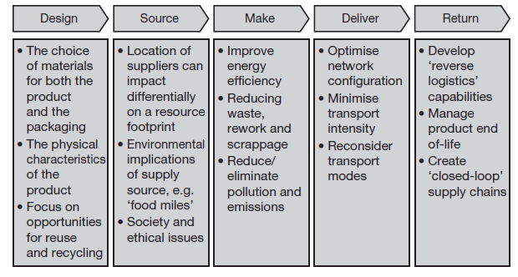

**Figure 2 Supply chain decisions impact the resource footprint**

Because so many natural resources are being depleted at an increasing rate, it is important that businesses understand these linkages. Some examples of the resource implications of supply chain decisions are described below.

***Design***

We have previously argued that the supply chain **‘starts on the drawing board’**, meaning that decisions that are taken regarding the design of the product can have a significant impact across the supply chain. This is particularly true when considering the supply chain’s **‘resource footprint’**. More and more companies are actively seeking to reduce the amount of packaging material that is used, for example, but there can be other, less obvious ways to improve resource sustainability. If those managers responsible for new product development are not aware of the resource implications of their design decisions, this may lead to the launch of products with a bigger than desirable resource footprint. For example, many high- tech products rely for their functionality on scarce materials such as the so-called **‘rare earth metals’** (e.g. dysprosium and neodymium) whose future availability may increasingly be limited.

***Source***

**‘Sustainable sourcing’** is emerging as a fundamental element of best practice procurement. one reason for this is that it is estimated that for a manufacturer somewhere between 40 and 60 per cent of their total carbon footprint lies upstream of their operations, whilst for retailers it can be as high as 80 per cent. Depending on where and how those upstream materials and products are sourced and made, there can be major differences in resource consumption.

For example, SAB miller, one of the world’s biggest beer producers, compared its ‘**water footprint’** in two different countries – South Africa and the Czech Republic. It found that the water used in crop production accounted for the vast majority of the total water footprint, but the South African footprint was greater than the Czech footprint because of a greater reliance on irrigation and higher levels of evaporation required to grow the crops used in South Africa. **It actually required 155 litres of water to produce a litre of beer in South Africa against 45 litres of water required to produce a litre of beer in the Czech Republic**.

***Make***

**Manufacturing processes affect the resource footprint primarily through their use of energy,** their relative efficiency and the creation and disposal of waste and toxic materials/effluents. In this age of outsourcing and offshore manufacturing it may not always be apparent to the customer what impact manufacturing strategy decisions can have on supply chain sustainability. However, it is evident that there are big differences in the energy efficiency of different factories and also in the waste they generate and how they dispose of it. Even the source of energy has sustainability implications.

For example a study conducted by the UK Carbon Trust looked at the different footprints created by a **UK national daily newspaper** when it used newsprint produced in Sweden compared to newsprint made in the UK. Because newsprint production is a highly energy-intensive manufacturing process and since most electricity generated in Sweden is from **renewable hydro sources**– unlike in the UK where **most electricity is generated from coal or gas –** the most sustainable manufacturing source was Sweden, not the UK!

***Deliver***

**Clearly decisions on the mode of transport will affect the carbon footprint of a supply chain as will the extent to which transport capacity is efficiently used.** However, the nature of the delivery network (i.e. the number, location and design of distribution centres, the use of hub and spoke arrangements, the extent of cross-docking, etc.) can have a wider impact on supply chain sustainability.

Many companies have used network optimisation models to help determine the shape of their distribution arrangements. However, **these models tend to optimise on a narrow definition of cost rather than taking into account the wider resource footprint that is created by the network. A new generation of network optimisation tools is now emerging which take account of the carbon footprint as well as the more conventional costs.**

***Return***

**‘Reverse logistics’ is the term usually used to describe the process of bringing products back, normally at the end-of-life, but also for recall and repair**. In the past, little attention was paid to the challenge of reverse logistics, often resulting in extremely high costs being incurred. Now, partly driven by increasingly stringent regulations – particularly on product disposal and reuse/recycling requirements – the issue has moved much higher up the agenda.

**Essentially the challenge today is to create ‘closed-loop’ supply chains that will enable a much higher level of reuse and recycling.** Clearly products must be designed with their end-of-life in mind, but also the logistics network employed must minimise the use of resources. Reverse logistics provides a major opportunity for companies to impact both their costs and their carbon footprint and should be viewed as an opportunity rather than a threat. Xerox is a good example of a company that actively seeks to design products and supply chain processes that enable a sustainable end-of-life recovery programme to be achieved.

**Reduce, reuse, recycle**

The 3Rs of sustainable supply chain management – **reduce, reuse and recycle** – are now starting to receive much more attention in most companies today. There is a growing realisation that not only is a strategy focused on improving the environmental impact of economic activity good for all who live on this planet, but because such strategies consume fewer resources the overall profitability of the business should also improve.

|  |
| --- |
| **Water: The next oil?** As the world’s population continues to increase and as climate change impacts on rainfall, there is an increasing mis-match between supply and demand for water. Supply chains are big consumers of water when all the different production and manufacturing processes involved from start to finish are considered. Already many organisations are actively measuring their ‘water footprint’ across the supply chain and are seeking alternative solutions to enable a reduction in the amount of water that is required to bring products to market. Water may indeed become the ‘next oil’ as shortages start to impact across a much wider arena.  Some examples of the water footprint of different products and commodities are shown below.  How much water does it take …  To make a cup of coffee? 140 litres  To make a litre of milk? 1,000 litres  To make a hamburger? 2,400 litres  To make a t-shirt? 2,500 litres  To make a pair of jeans? 10,850 litres  To produce a kilogram of beef? 16,000 litres  **Source: WWW.WATERFooTPRINT.oRG** |

**Many companies are now actively seeking to create marketing strategies that emphasise the ‘greenness’ of their supply chains.** Whilst the more cynical observers may dismiss these moves as opportunism – what some have dubbed ‘greenwash’ – there can be no question that customers and consumers in markets around the world are starting to demand that suppliers reduce their various footprints.

**Strong evidence is emerging that consumers are increasingly basing their purchasing behaviour on ethical and environmental criteria.**

In some instances major retailers such as Wal-mart and Tesco are seeking to improve their supply chain footprints and are demanding action from their suppliers to improve their performance on the 3Rs, i.e. to demonstrate how they are reducing the use of materials such as packaging and how they are designing products that can be reused or recycled. Both Wal-mart and Tesco (and other retailers too) intend to provide information on the labels of the products they sell detailing the overall environmental impact of those items. To do this they are working closely with their suppliers to ensure that their supply chain arrangements are sustainable and that they continue to seek innovative ways to improve the end-to- end environmental footprint.

For example, **Tesco recognised that glass bottles, because of their weight, add significantly to transport intensity and overall carbon emission.** By working with suppliers to create lighter weight wine bottles, Tesco reduced its annual glass usage from one single supplier by 2,600 tonnes – a 15 per cent saving. Further savings were achieved by importing wines into the UK from Australia in bulk and then bottling them in lightweight glass in the UK.

**Further pressure on businesses to reduce their environmental footprints is coming from government regulation,** often in the form of Emission Trading Schemes (ETS) or so-called ‘Cap and Trade’ legislation. For example, the European Union’s Emissions Trading Scheme has recently been extended to cover a greater range of industries and is based on the principle that companies have a **basic allowance for carbon emissions** – if they go beyond that level they have to buy additional allowance from other companies who do not fully use their own allowance. Similar schemes are currently contemplated by governments around the world and in time their impact is likely to be significant.

**Since, as we have noted, most of a typical business’s total environmental foot- print lies in its wider supply chain, particularly upstream of its own operations,** the need for supply chain managers to become more involved in managing this footprint becomes apparent. Unless upstream suppliers are able to reduce their own footprint the additional costs that they will incur will inevitably end up in their cost of goods sold – and ultimately in the price of the products in the final marketplace.

**The impact of congestion**

**One of the key issues when considering sustainable supply chain solutions is traffic congestion and the related infrastructure issues**. In probably the majority of countries, developed and developing, the creation of logistics infrastructure has not kept pace with the level of economic activity. This is true for all types of infrastructure, including roads, ports and railways. Gridlock on motorways, container vessels waiting to unload at ports and bottlenecks on the railways are common occurrences in many countries and add to carbon emissions as well as adding cost to suppliers and customers alike.

There have been a number of causes of this problem, including increased global trade, lack of investment in capacity and the widespread adoption of just-in- time practices:

***increased global trade***

**With the growth in offshore manufacturing and the emergence of new markets, alongside the removal of trade barriers, the flow of products across borders has increased dramatically.** At the same time the size of many container vessels has increased significantly – the new generation of container ships can carry upwards of 10,000 TEUs (20 foot equivalent), which if laid end-to-end would stretch for 60 kilometres or 37 miles! When unloaded each of these containers may need to be stacked on the dockside before being loaded out to trains or trucks, further adding to congestion. Furthermore, in recent years the increase in container security requirements has led to additional delays at both the points of origin and destination.

***lack of capacity***

**Paradoxically in some developed countries environmental concerns have led to unwillingness to build more infrastructure such as new motorways or port extensions.** Also, there has been resistance in countries such as the UK to introduce bigger trucks which might actually reduce congestion, since fewer would be required. **Equally in developing countries the sheer scale of the investment required to meet the demand is daunting.** India is a good case in point where because of a lack of previous investment there is an overwhelming shortage of capacity on the roads, railways and at the ports – particularly in the face of burgeoning demand.

***Just-in-time practices***

**Over the last 50 years there has been a significant uptake across all sectors and supply chains of the philosophy and practice of just-in-time (JIT).** Essentially this has led to smaller but more frequent movements of products and materials. Even though many of those who have adopted JIT have attempted to mitigate its effects through **aggregation and consolidation there can be no doubting that it has contributed to an increase in shipments and movements.**

In the past it could be argued that the saving in inventory holding costs more than covered the additional transport cost. However, now **that concern with environmental issues has become much more prevalent,** JIT in its crudest form will increasingly be questioned. The challenge for supply chain managers is to find a solution that enables the benefits of JIT to be gained without incurring the potential environmental disadvantages.

While congestion will probably continue to affect logistics management for many years to come, particularly as economic growth and development continue, **there is likely to be some alleviation as a result of the application of what might be termed ‘smart logistics’ and ‘intelligent transport’.** The idea here is to combine the opportunities that exist for greater partnership and collaboration, both vertically and horizontally, in the supply chain with advanced information and communication technology.

Smart logistics works by aggregating and combining individual shipments into consolidated loads for final delivery. ‘Cross docking’ is an example of this idea whereby different suppliers ship complete truck loads to a distribution centre, typically with each pallet bar-coded or RFID-tagged with product and destination details, for resortment and consolidation with other shipments to the same final destination. The same principle can be used utilising ‘logistics platforms’ on the edge of large cities or conurbations to reduce individual deliveries to congested locations.

When **advanced IT solutions such as dynamic vehicle routing and scheduling and intelligent agent modelling** are used alongside these collaborative strategies, many things become possible – particularly enabling the better management of constrained capacity against a backdrop of uncertain demand.

References

1. World Commission on Environment and Development, *our common Future*, oxford University Press, 1987.
2. Elkington, J., *cannibals with Forks: The Triple bottom line for 21st century business*, Capstone Publishing, oxford, 1997.
3. Stern, N., *Stern review on the Economics of climate change*, Hm Treasury, london, 2000.
4. Gore, A., *an inconvenient Truth*, Bloomsbury, london, 2006.
5. Friedman, T., *The World is Flat*, Allen lane, UK, 2005
6. Botte, H., meyer, T. and Stuchtey, m., ‘An energy efficiency resolution in supply chains’, Mckinsey Quarterly, August 2009.
7. Holliday, C.o., Schmidheing, S. and Watts, P., Walking the Talk: The business case for Sustainable Development, Bennett-Koehler Publishers Inc., San Francisco, 2002.
8. Brickmann, C. and Ungerman, D., ‘Climate change and supply chain management’, Mckinsey Quarterly, July 2008.
9. SAB miller and World Wildlife Fund, Water Footprinting: identifying and addressing Water risks in the Value chain, SAB miller, london, 2009.
10. Carbon Trust, carbon Footprints in the Supply chain, Carbon Trust, london, 2006.
11. maslennikova, I. and Foley, D., ‘Xerox’s Approach to Sustainability’, interfaces, vol. 30, No. 3, 2000.
12. Butner, K., Geuder, D. and Hittner, J., Mastering carbon Management: balancing Trade-offs to optimise Supply chain Efficiencies, IBM Global Services, 2008.